Tangram Pythagoras - INOVAtor

1. Untitled Scene

1.1 Untitled Slide


1.2 Untitled Slide
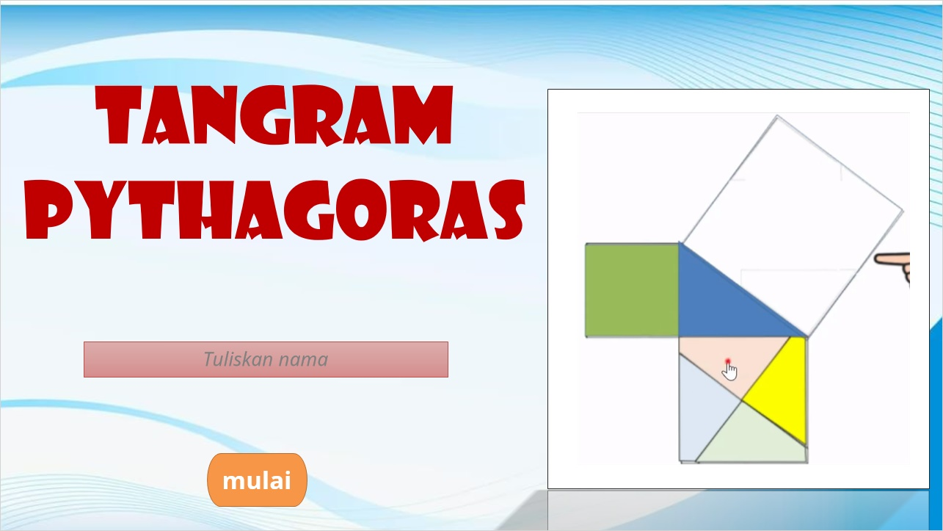

2. Untitled Scene

2.1 Untitled Slide


2.2 Drag and Drop
(Drag and Drop, 10 points, 1 attempt permitted)
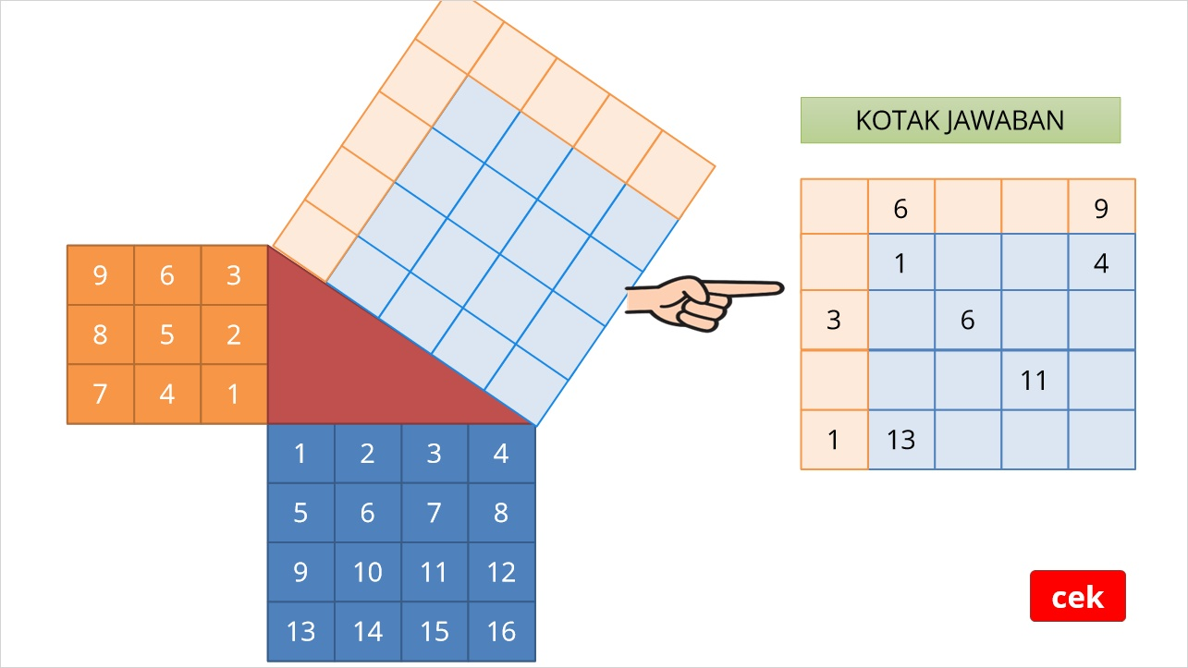

Benar (Slide Layer)
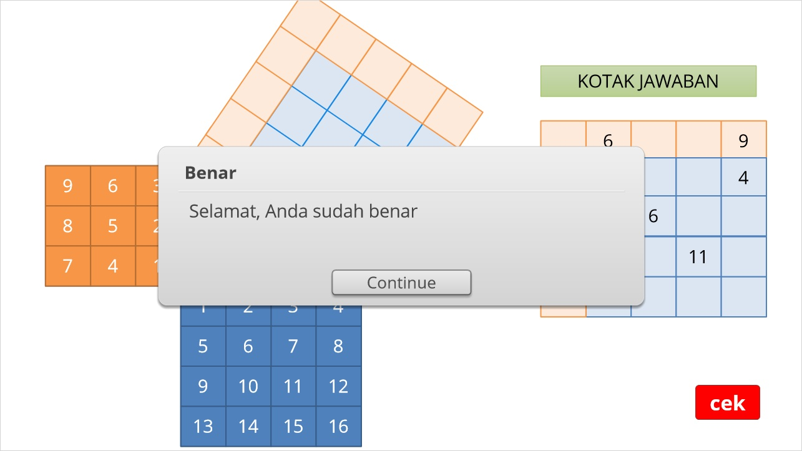

Salah (Slide Layer)
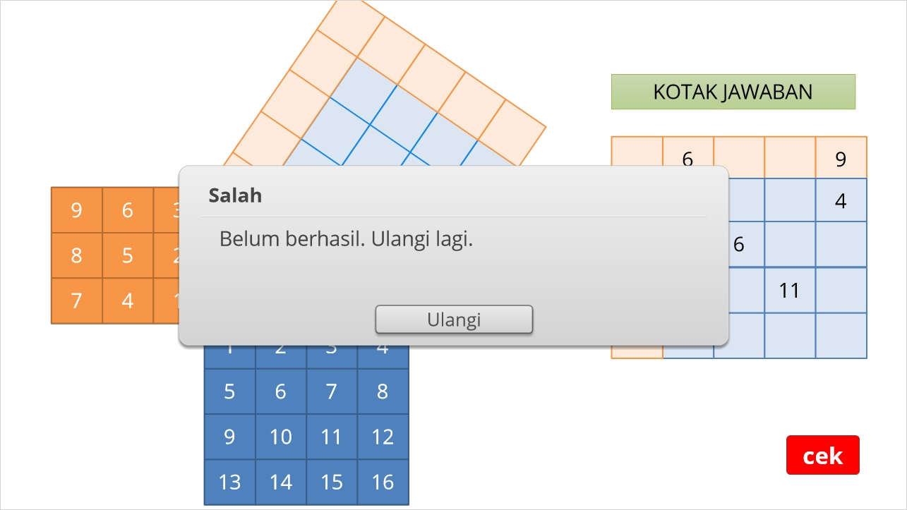

2.3 Untitled Slide


2.4 Drag and Drop
(Drag and Drop, 10 points, 1 attempt permitted)
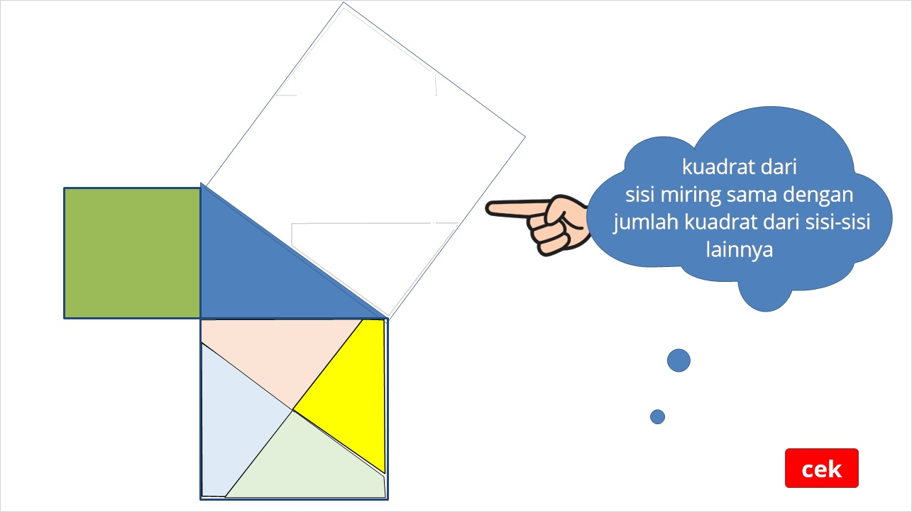

Benar (Slide Layer)
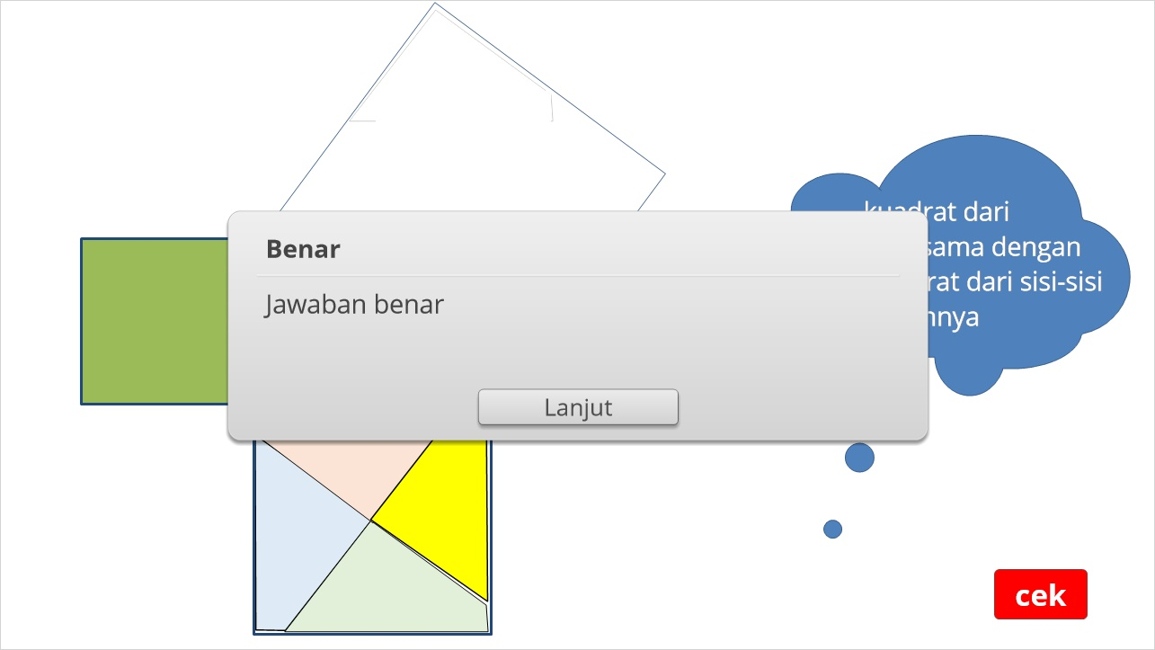

Salah (Slide Layer)
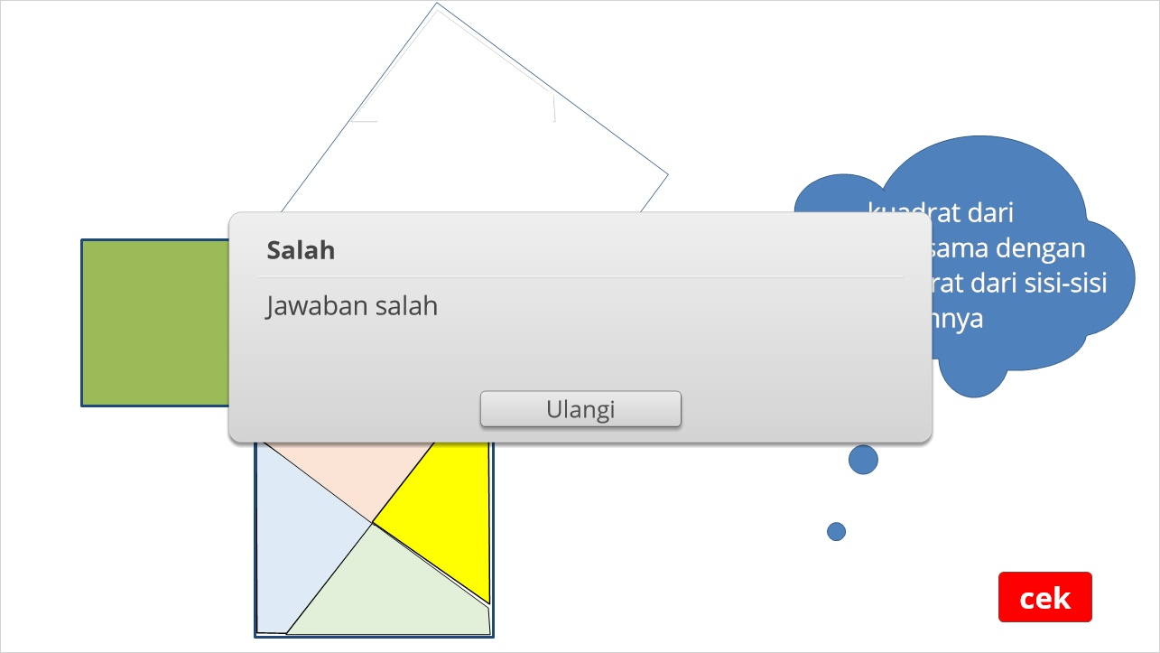

2.5 Untitled Slide


2.6 Drag and Drop
(Drag and Drop, 10 points, 1 attempt permitted)
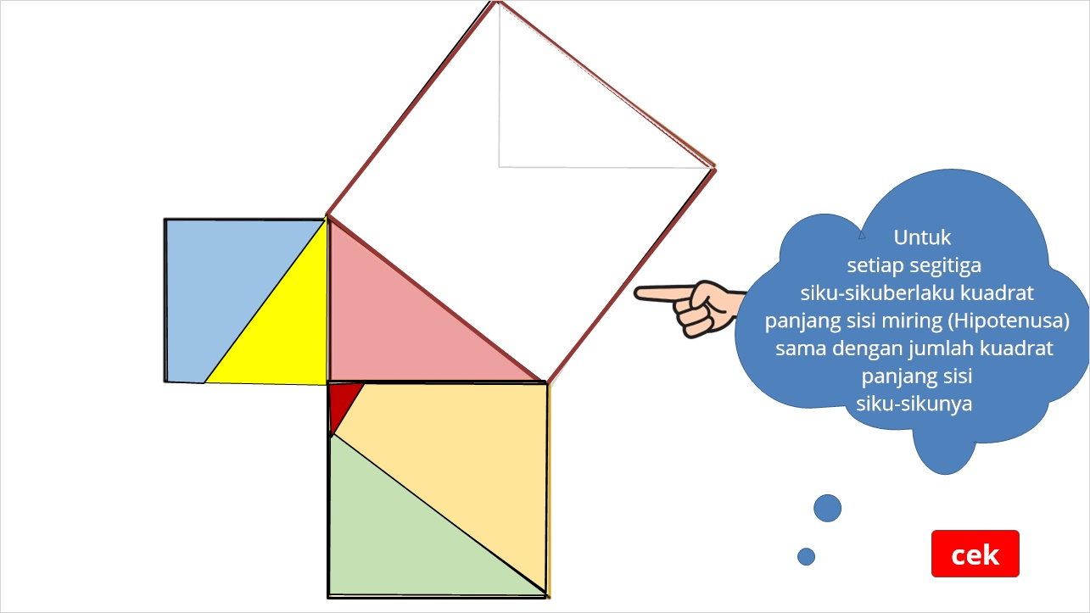

Benar (Slide Layer)
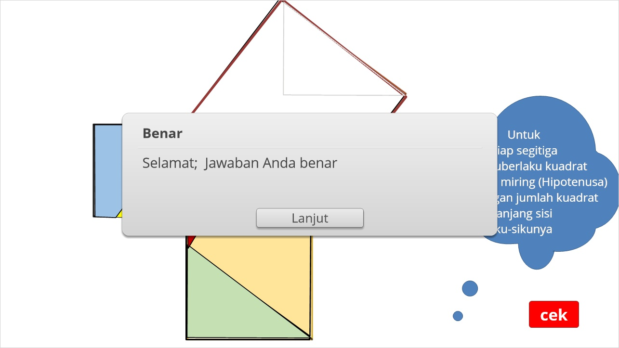

Salah (Slide Layer)
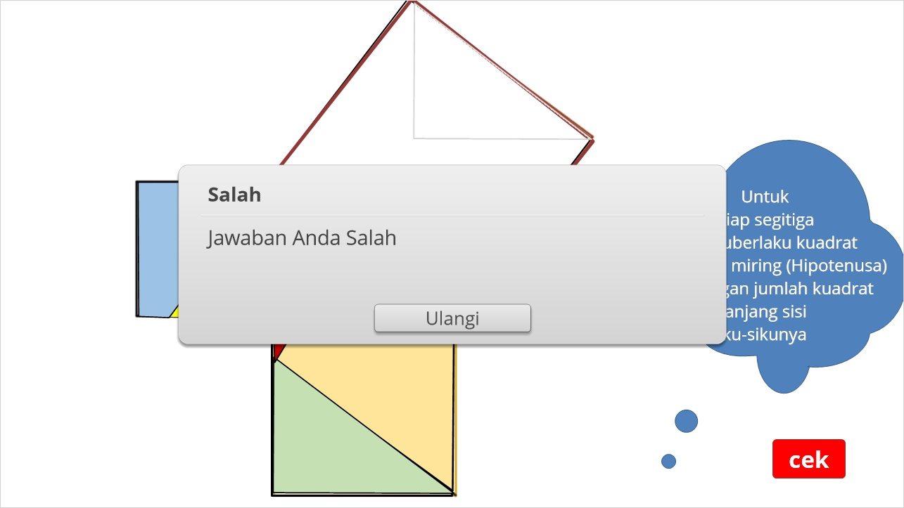

2.7 Untitled Slide


2.8 Drag and Drop
(Drag and Drop, 10 points, 1 attempt permitted)
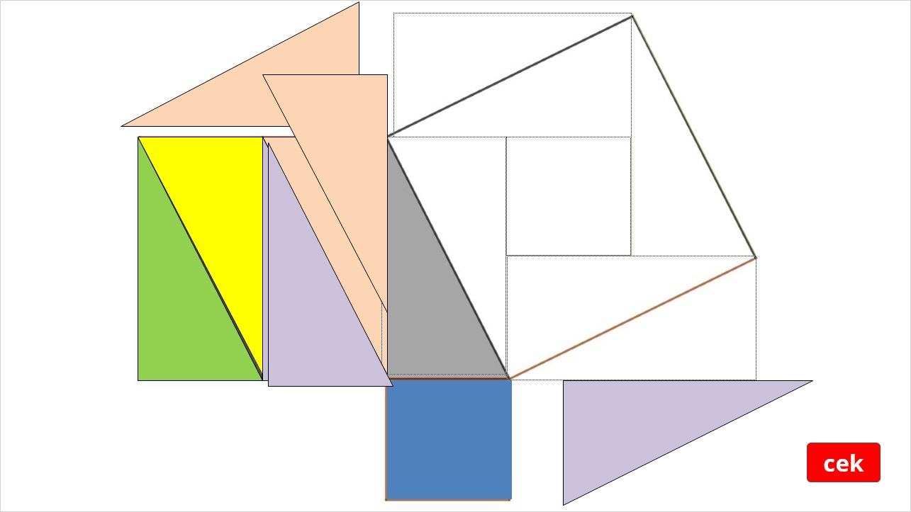

Benar (Slide Layer)
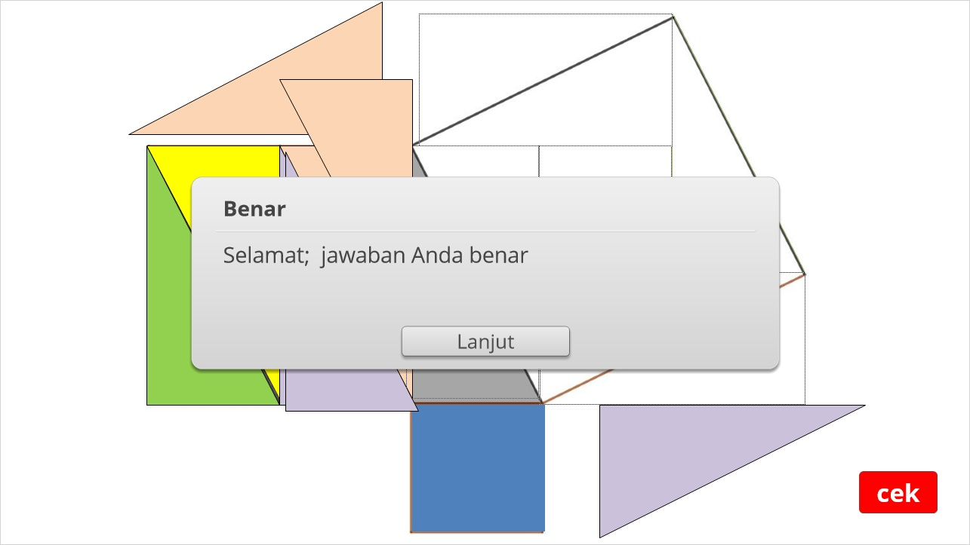

Salah (Slide Layer)
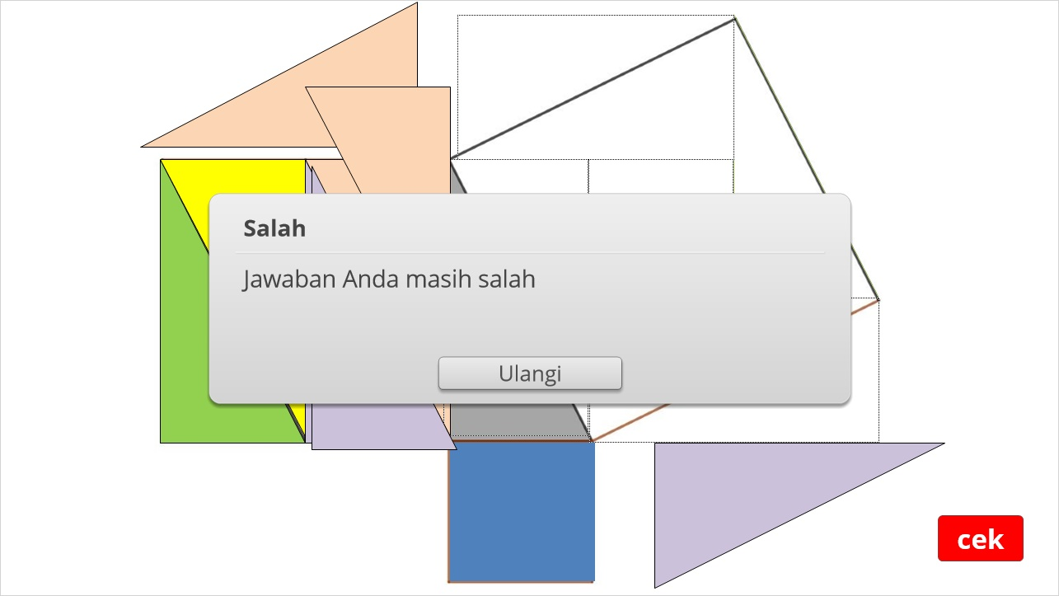

2.9 Untitled Slide


2.10 Drag and Drop
(Drag and Drop, 10 points, 1 attempt permitted)
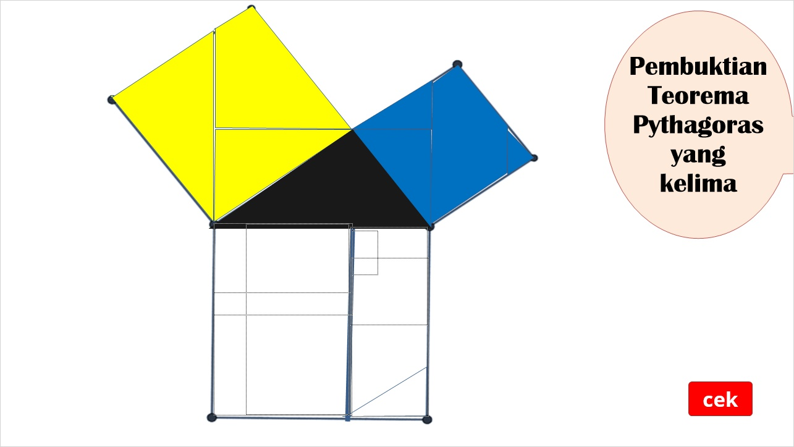

Benar (Slide Layer)
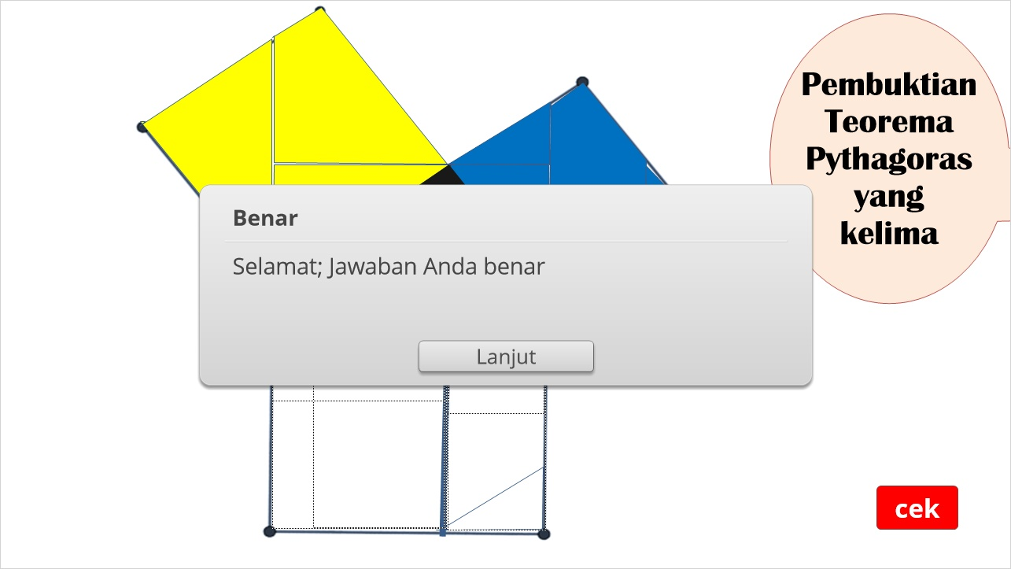

Salah (Slide Layer)
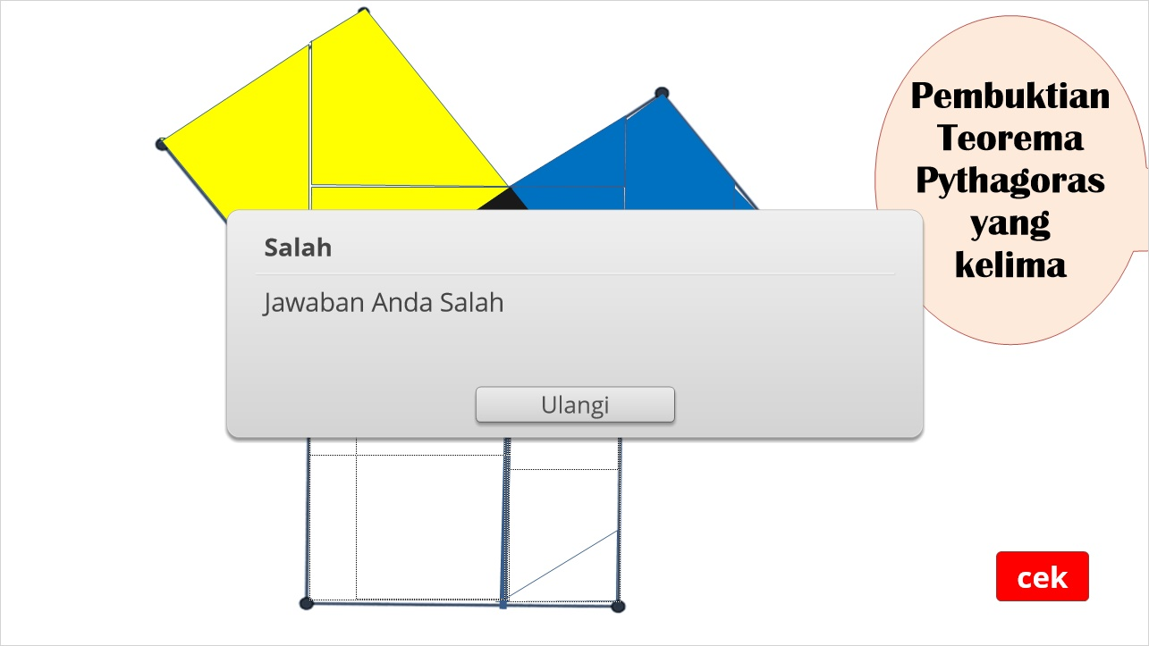

2.11 Untitled Slide


3. Untitled Scene

3.1 Untitled Slide
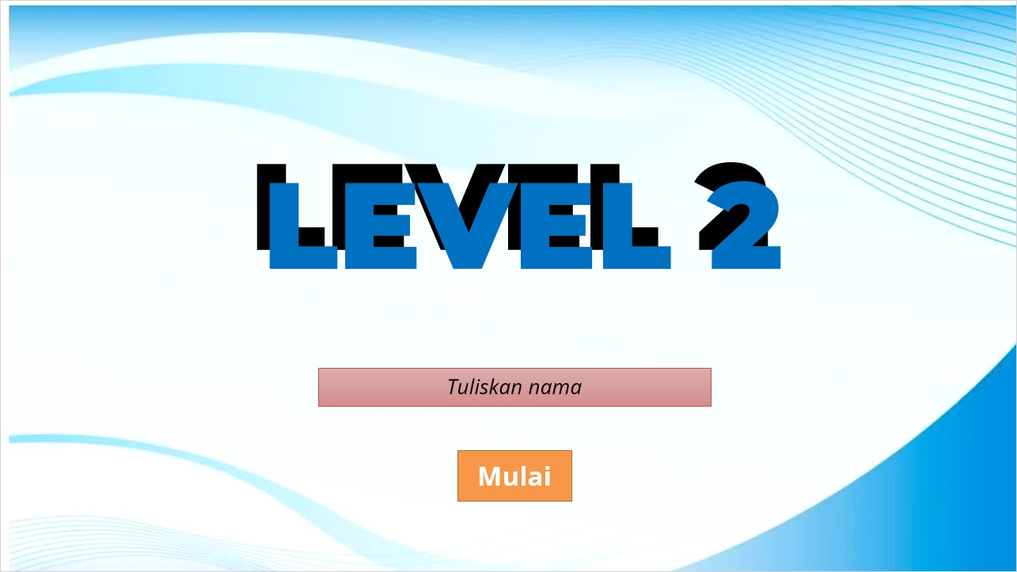

3.2 Pick One
(Pick One, 15 points, 1 attempt permitted)
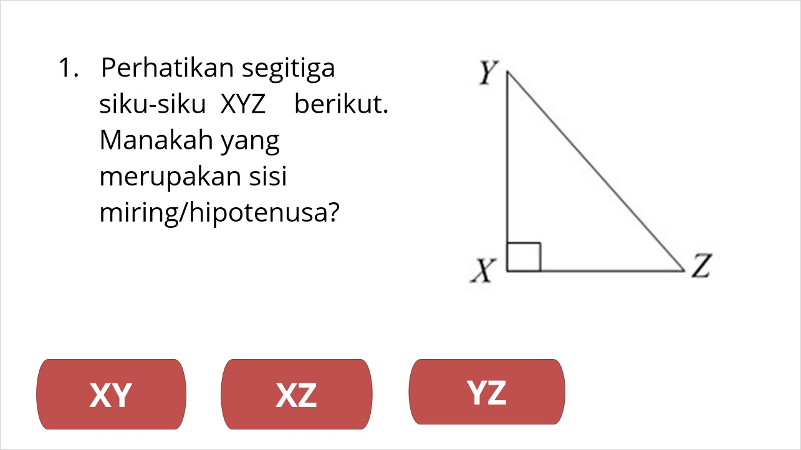
Correct | Choice
 | XY
 | XZ
X | YZ

3.3 Pick One
(Pick One, 15 points, 1 attempt permitted)
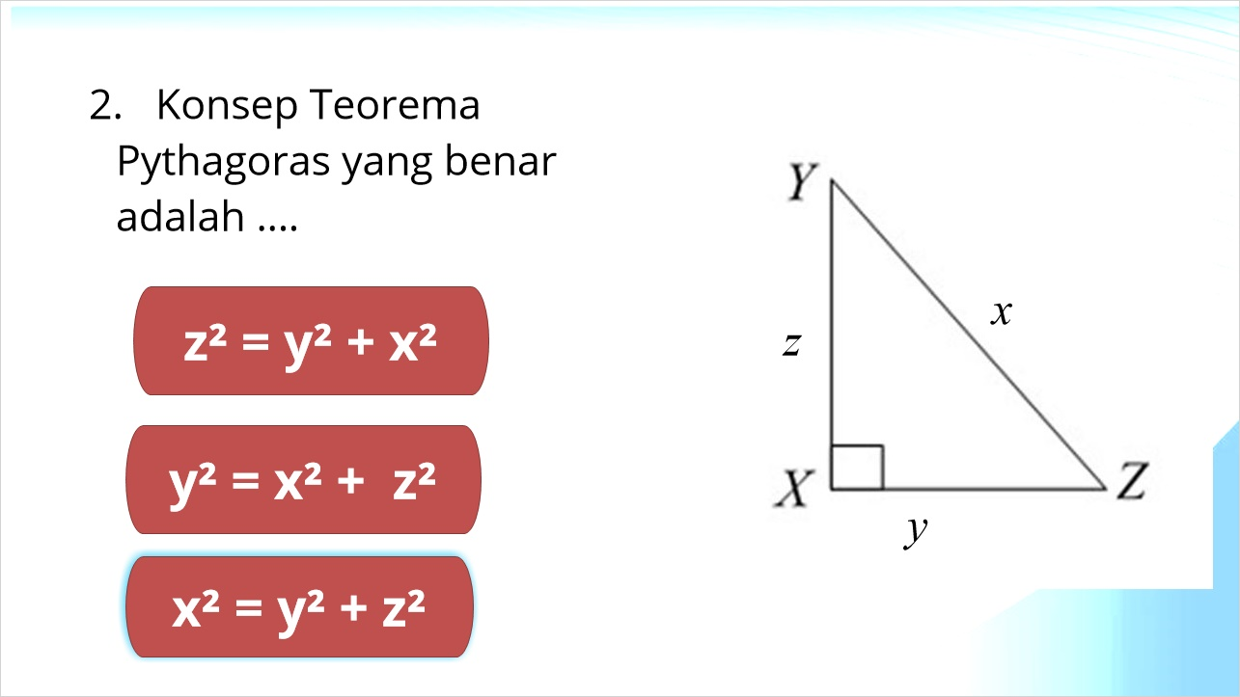
Correct | Choice
 | z² = y² + x²
 | y² = x² + z²
X | x² = y² + z²

3.4 3. Selesaikan penyelesaian Teorema Pythagoras dalam

menentukan nilai p pada segitiga siku-siku berikut

ini. Isilah di kotak-kotak yang telah disediakan!
(Text Entry, 20 points, 1 attempt permitted)
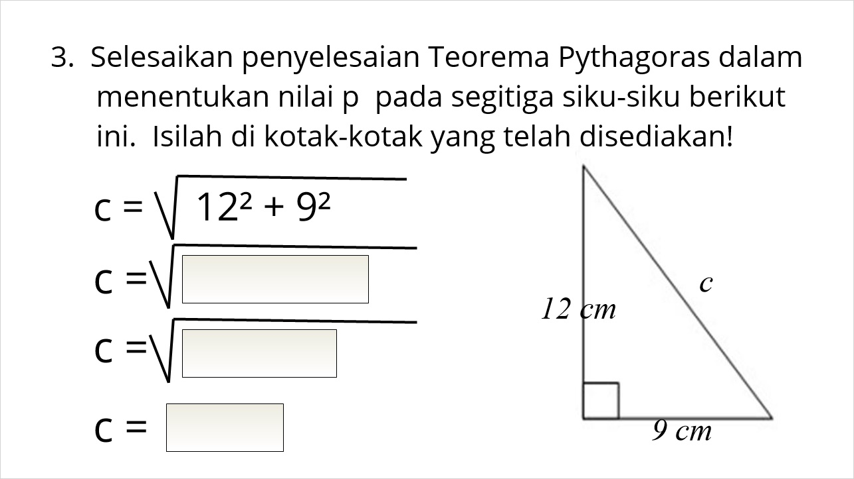

Feedback when correct:
That's right! You selected the correct response.
Feedback when incorrect:
You did not select the correct response.

Correct (Slide Layer)
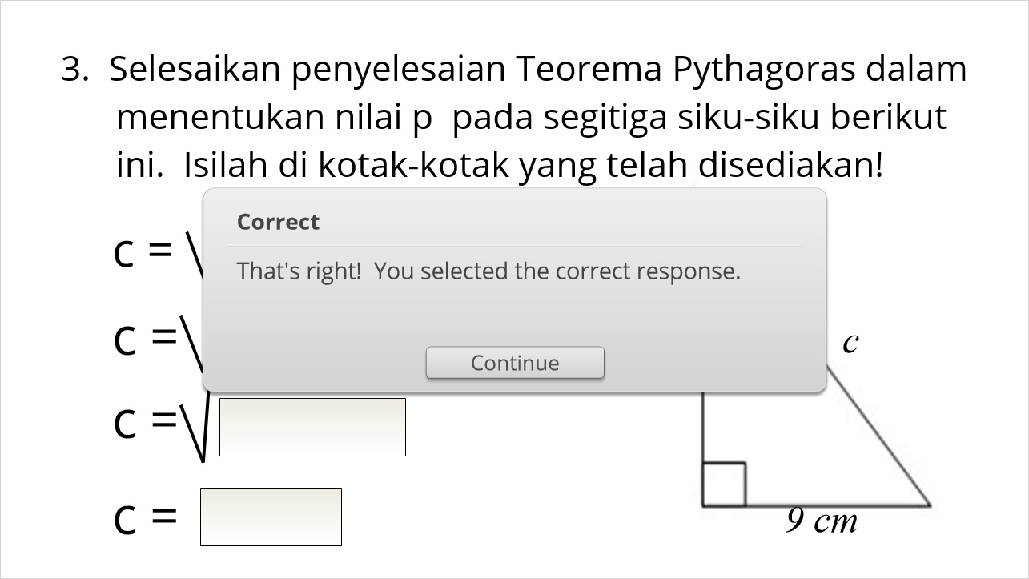

Incorrect (Slide Layer)
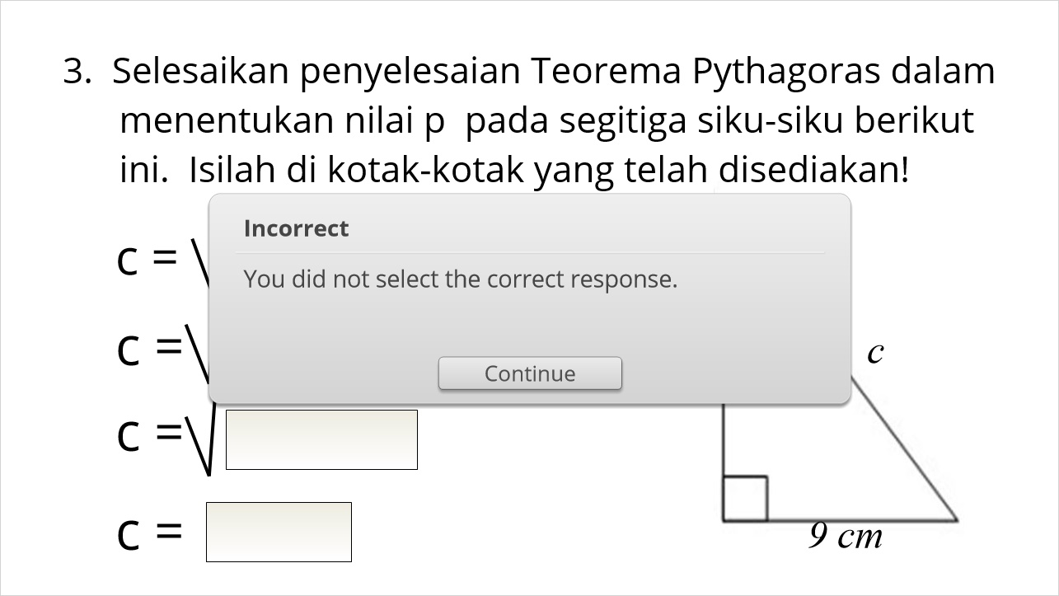

3.5 Pick Many
(Pick Many, 15 points, 1 attempt permitted)
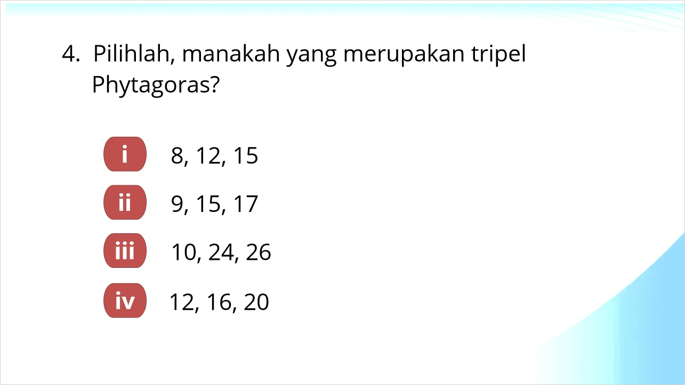
Correct | Choice
X | iii
X | iv
 | i
 | ii

3.6 Pick Many
(Pick Many, 20 points, 1 attempt permitted)
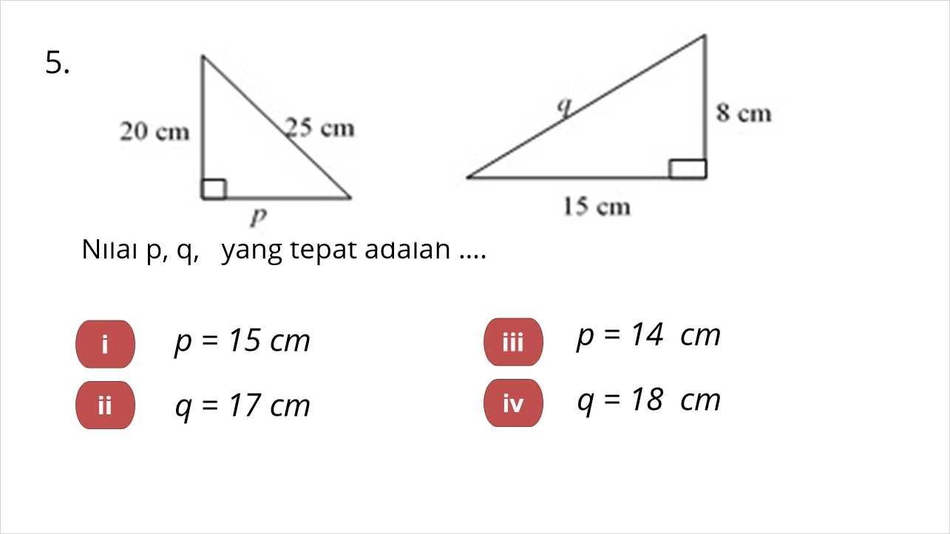
Correct | Choice
X | i
X | ii
 | iii
 | iv

3.7 Pick One
(Pick One, 15 points, 1 attempt permitted)
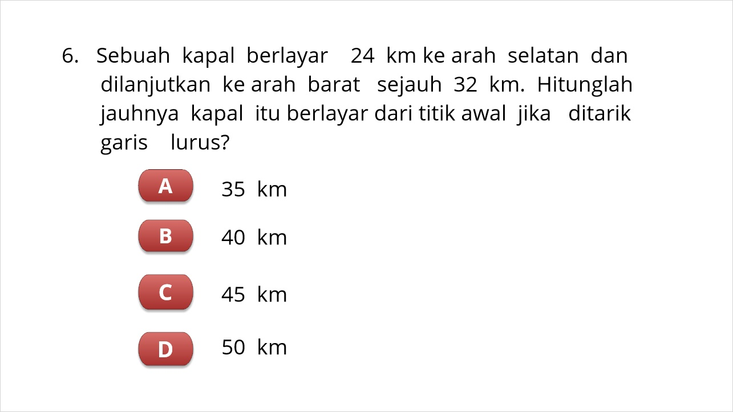
Correct | Choice
 | A
 | C
X | B
 | D

3.8 Results Slide
(Results Slide, 0 points, 1 attempt permitted)
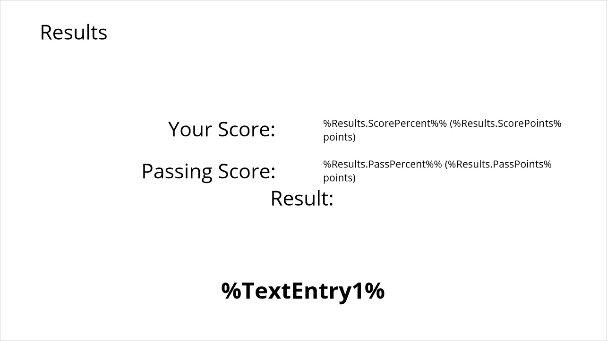

Results for
3.2 Pick One
3.3 Pick One
3.4 3. Selesaikan penyelesaian Teorema Pythagoras dalam
menentukan nilai p pada segitiga siku-siku berikut
ini. Isilah di kotak-kotak yang telah disediakan!
3.5 Pick Many
3.6 Pick Many
3.7 Pick One

Result slide properties
Passing  Score | 80%
End quiz after | 00:15:00 minutes
Start Timer | With first slide
Timer format | Elapsed

Success (Slide Layer)
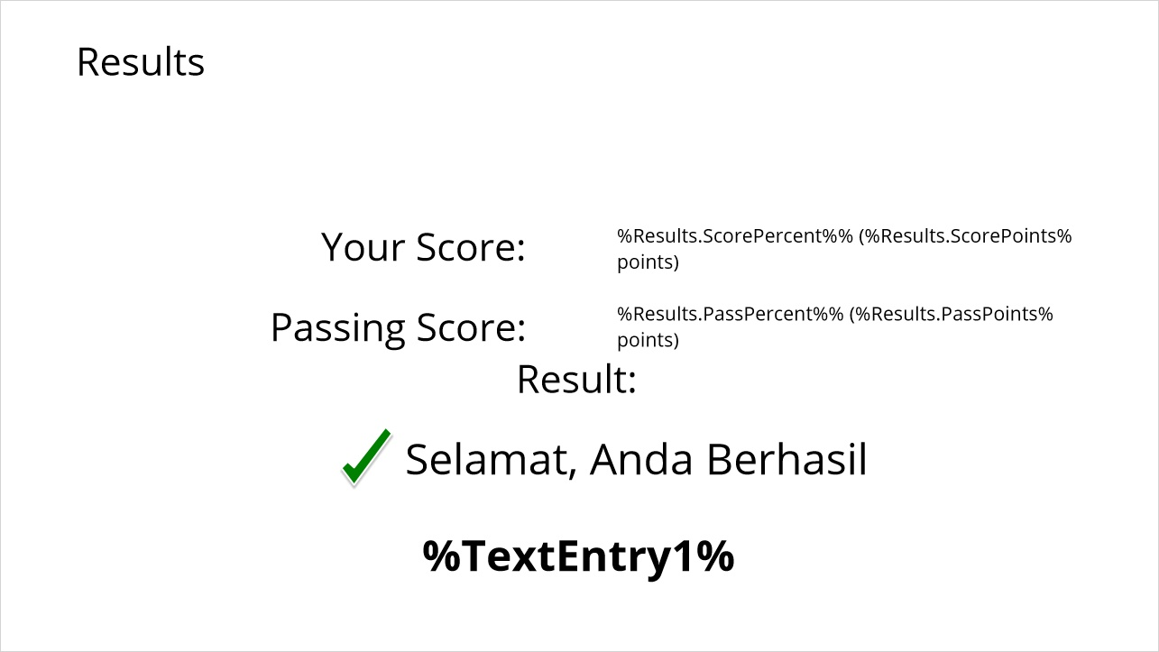

Failure (Slide Layer)
